**SHIVER GAMES ANNOUNCES LUCIUS III**

**The Son of the Devil takes his final journey in Lucius III, that is set to release in late 2018.**

**HELSINKI (August 27, 2018) -** Shiver Games is excited to announce that **Lucius** is returning to **STEAM** in **2018** for the last time. In a whole new narrative experience, he now returns to his old neighborhood of Winter Hill. The path will be a difficult one, with trials and tribulations waiting ahead. Has he made the right choices? Is it finally time to end it all?

The game will be priced at $19.99 in **STEAM** and is now available for wishlisting.

Announcement Trailer : [**https://youtu.be/H7Ud0t5ytCQ**](https://youtu.be/H7Ud0t5ytCQ)

**Lucius III returns to its roots in terms of both gameplay and story. The game will play as a narrative adventure, focused around the atmospheric little town of Winter Hill - the very same town where Lucius spent his first six years.**

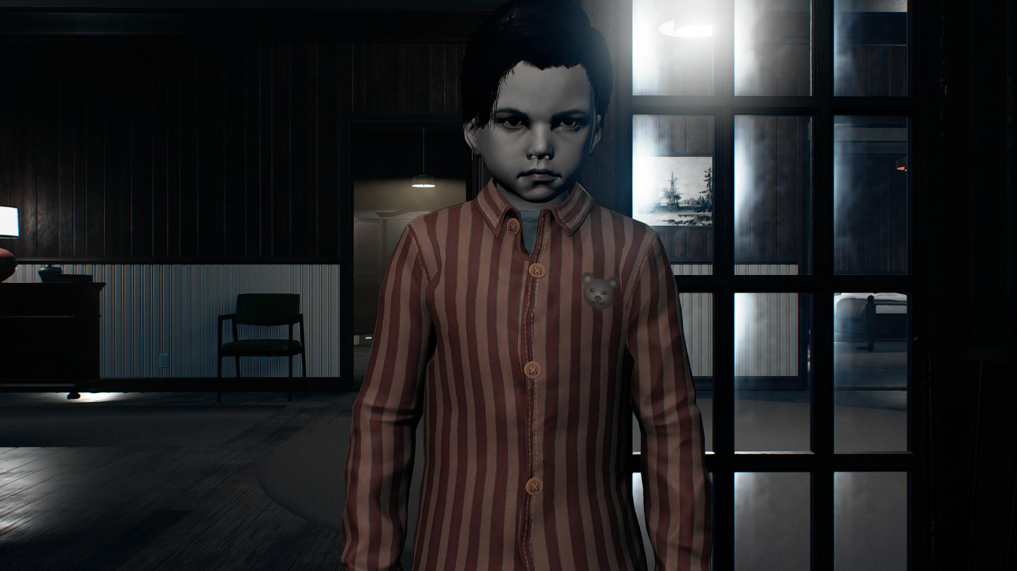

Lucius continues to fulfill the prophecy of the rapture, and finally we get to see where the roads take us. The story will include his signature gruesome violence and disturbing images, but this time there will be some heartfelt moments of regret and sorrow.

Press Kit: <http://shivergames.com/pressrelease/PressKit2018>

Steam Store Page :<https://store.steampowered.com/app/513290/>

**Game features:**

* Experience an In-depth and carefully crafted story, which takes the player through a wide range of emotional experiences.
* Feel the full experience of playing the villain protagonist.
* Experience the atmospheric and detailed environments.
* Use powerful magical abilities to help your cause.
* Explore the seamless little town of Winter Hill.
* Over 20 tracks of original music that compliments to the atmosphere of the game.

**More information:**

Press Kit:<http://shivergames.com/pressrelease/PressKit2018>

Official Site: [http://www.lucius3.com/](http://lucius3.com)

YouTube Link: [www.youtube.com/shivergames](http://www.youtube.com/shivergames)

Steam: <https://store.steampowered.com/app/513290/>

Press Contact: pr@shivergames.com – Johannes Aikio

**About Shiver Games:**

Shiver Games is an independent game developer from Helsinki, Finland, founded in 2010. Lucius, Shiver Games’ first title, was released in October 2012. Since then, the company has continued working on the saga passionately.

Please visit the official website: [www.shivergames.com](http://www.shivergames.com/) for more information.

All other trademarks are properties of their respective owners.