**LUCIUS GETS A DATE: DECEMBER 13th**

**The Devil’s son contemplates his destiny in Lucius III, that is set to release next month.**

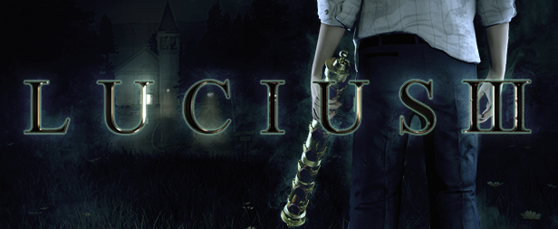

**HELSINKI (November 15, 2018) - Shiver Games** is pleased to announce the **Lucius** saga continues next month with Lucius III set to launch **December 13th** on PC. To accompany the announcement, Shiver includes some gameplay videos showing off some of the mysterious environments in the game.

The game will be priced at $19.99 on **STEAM** and is now available for wishlisting. Lucius III will also be available through other various digital platforms upon release

The Raven: <https://youtu.be/2mnAl1R5goI>

The Freemans: <https://youtu.be/9tJ41AIv-4E>

The Town Hall: <https://youtu.be/-I3UdpIxZjk>

The Amusement Park: <https://youtu.be/Ljk-ik3JbPM>

**Lucius III returns to its roots in terms of both gameplay and story. The game will play as a narrative adventure, focused around the atmospheric little town of Winter Hill - the very same town where Lucius spent his first six years.**

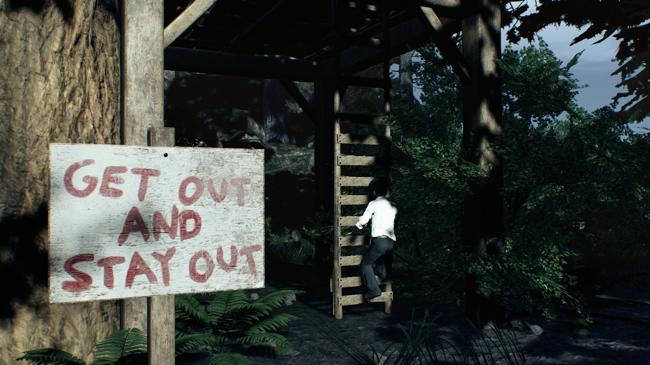

Lucius continues to fulfill the prophecy of the rapture, and finally we get to see where the road takes us. The story will include his signature gruesome violence and disturbing images, but this time there will be some heartfelt moments of regret and sorrow.

Press Kit: <http://shivergames.com/pressrelease/PressKit2_2018>

Steam Store Page: <https://store.steampowered.com/app/513290/>

Announcement Trailer: <https://youtu.be/H7Ud0t5ytCQ>

**Game features:**

* Experience an In-depth and carefully crafted story, which takes the player through a wide range of emotional experiences.
* Feel the full experience of playing the villain protagonist.
* Experience the atmospheric and detailed environments.
* Use powerful magical abilities to help your cause.
* Explore the seamless little town of Winter Hill.
* Over 20 tracks of original music that compliments to the atmosphere of the game.

**More information:**

Official Site: [http://www.lucius3.com/](http://lucius3.com)

YouTube Link: [www.youtube.com/shivergames](http://www.youtube.com/shivergames)

Press Contact: pr@shivergames.com – Johannes Aikio

**About Shiver Games:**

Shiver Games is an independent game developer from Helsinki, Finland, founded in 2010. Lucius, Shiver Games’ first title, was released in October 2012. Since then, the company has continued working on the saga passionately.

Please visit the official website: [www.shivergames.com](http://www.shivergames.com/) for more information.

All other trademarks are properties of their respective owners.